**The Fourth Branch Website**

The following document is an explanation of what is to be included in The Fourth Branch website. A dash mark (-) will indicate a note, and will be followed by either a **P.** for Programmer or **D.** for Designer.

**Standard Header**

The standard header will appear at the top of every page and will look like the following image:

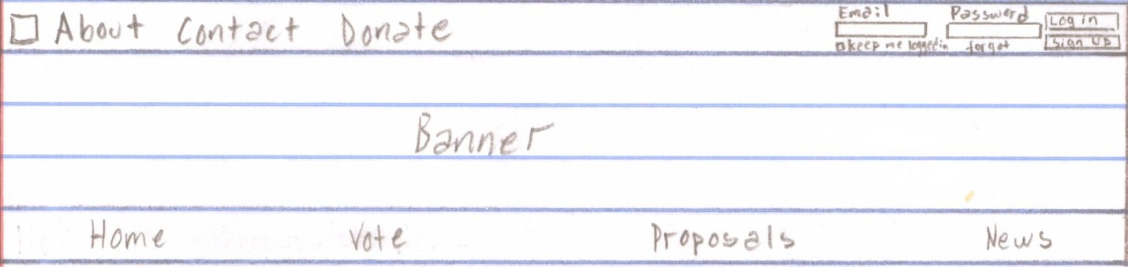

* **D.** Where it says banner is where the design for the header will go.
* **P.** The designer will provide us with an image to be used as our banner.

With the exception of the upper right hand corner, the banner will remain the same throughout the entire website. The square in the upper left corner will be a symbol that represents The Fourth Branch **(DESIGNER).** The three words after the square are tabs which will redirect the user to three separate pages. The About and Contact page will consist of the standard header, text, and the bottom banner**. (Contact Page for user to delete account).** The Donate page will consist of the standard header, text, a PayPal feature that will allow users to make donations to our website, and a standard bottom. The tabs on the bottom row of the header will allow the user to navigate the website; these tabs will be addressed later **(DESIGNER).**

This is the view of the header when a user has not logged in to their account. In the upper right hand corner the top line reads “Email” followed by “Password” and underneath them are two rectangles for the user to input their information. Under the email rectangle there is an option for the user to check whether they wish to remain signed in and under the password rectangle is a hyperlink that should read “forgot password?” To the right of the password rectangle is the Log in and Sign up buttons.

Whenever a user clicks on the sign up button a window will pop up and the registration process will begin. The window will look like the following image:



There are two separate accounts that a user can sign up for: Individual or Organization. Once the user chooses which account they will sign up for a drop down menu will appear. First we will talk about the sign up process for the Individual profiles. Once the user clicks Individual the window will look like the following image:

* **D.** Once an option is chosen, the area that reads “Are you an” will fade out and an image will fade in depending on which option is chosen. If the Individual tab is chosen an image representing an individual will fade in and if the organization tab is chosen then an image representing a group will fade in. These images must be designed.

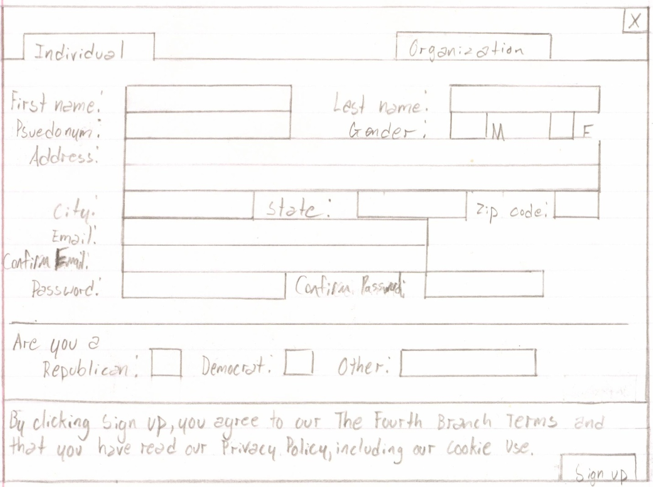

* **D.** Find a space in the upper section to include an option to put in Date of Birth (DOB)

Everything in the upper section is mandatory, but the question regarding the user’s Political stance is optional. “The Fourth Branch Terms”, “Privacy Policy”, and “Cookie use” should all be hyperlinks to their respective pages, which will only contain the standard header, text, and the bottom banner. Once the user clicks sign up, the following will pop up:

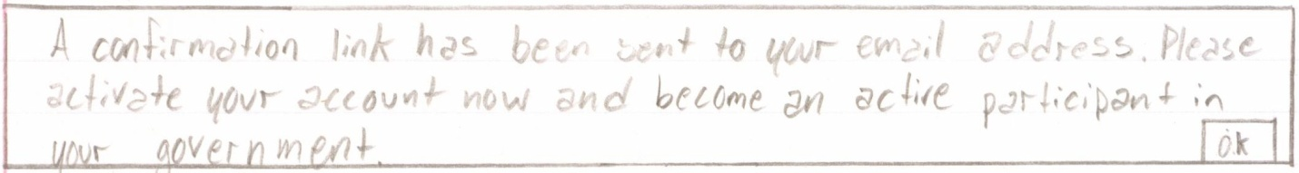

The user will only be able to access their account once they have confirmed their activation link through their email address.

Now we will review the registration process for organizations. If the user chooses to click organization then the drop down will look like the following image:

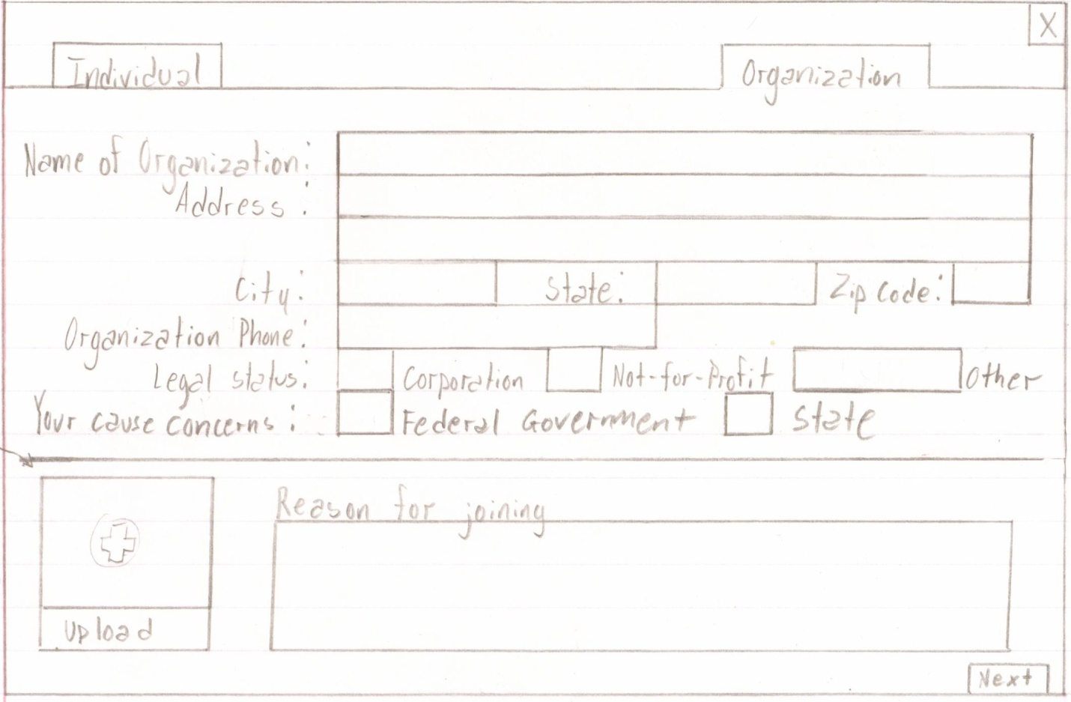

* **D.** The plus sign in the square is what we used to indicate upload, but feel free to come up with your own symbol.

All of the information in the organization registration process is mandatory. Once the organization uploads an image it should appear in the square that says upload. If the organization chooses to change the image they can hover their cursor over the image and an x should appear to allow the organization to upload another one that would simply replace this image. When the organization clicks next the window will proceed to the second part of the process, and it will look like the following image:

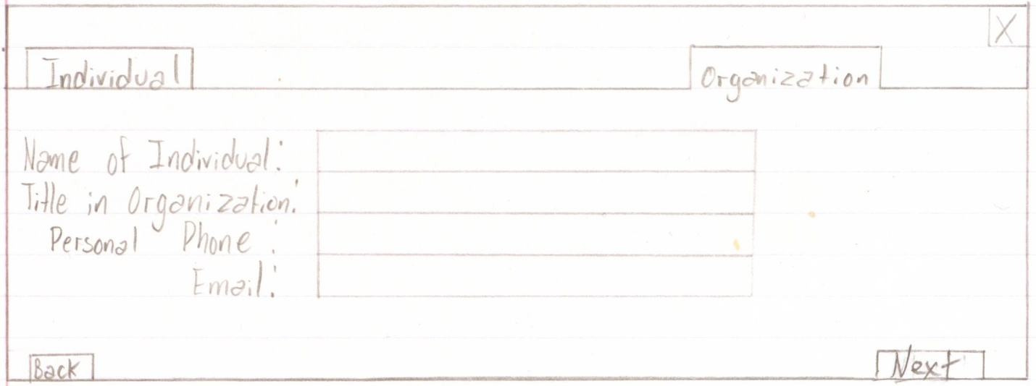

The organization cannot proceed until after they have finished completing the entire form. When the organization clicks the next button, the window will go to the last step in the registration process.

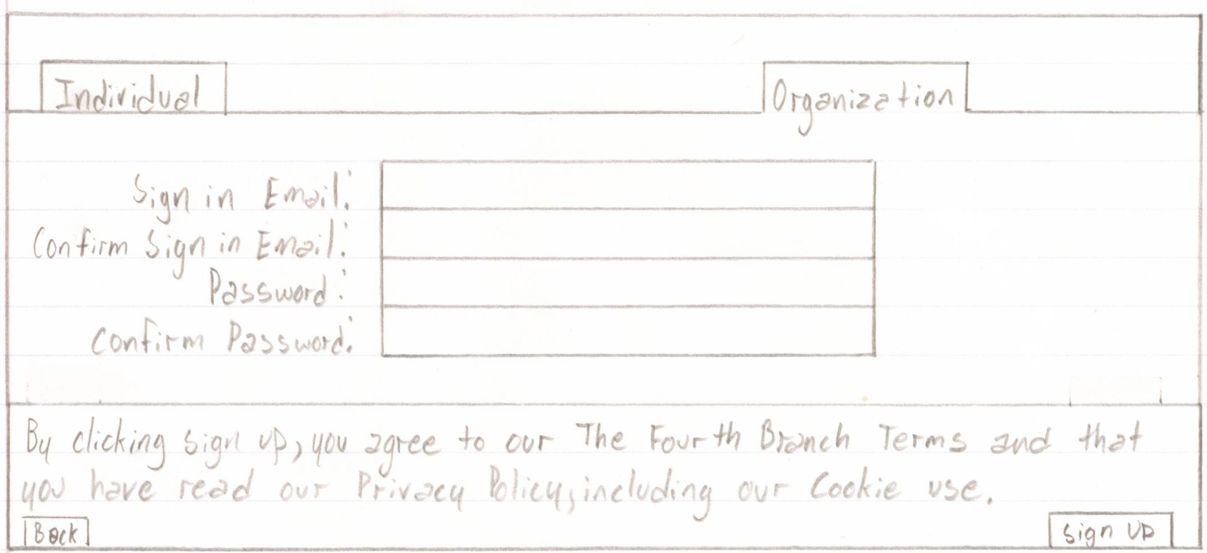

The key difference between the Individual profiles and the Organization profiles, as far as the registration form is concerned, is that Individual Profiles can begin using the website as soon as they confirm their email but organization profiles must be approved by the website administrators. Once the user clicks Sign Up a text box will appear, and it will read, “Thank you for submitting an application for an organization profile. We will review the information that you have submitted and respond with either an approval or denial via the email address that you have provided”.

Once a user is signed into The Fourth Branch the standard header will appear as follows:

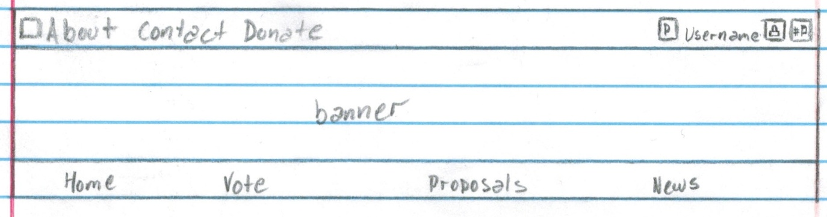

Everything remains the same with the exception of the upper right hand corner. The square with the “P” in it will be where the photo of the user who is logged in will be, and beside it will be their username. Both the photo and the username will be hyperlinks that take the individual back to their profile. The square to the right of the username will have a lock in it and will stand for privacy features/security **(DESIGNER - needs to decide on the little lock image).** When the lock is clicked on, a drop down menu will appear and it will look like the following image:

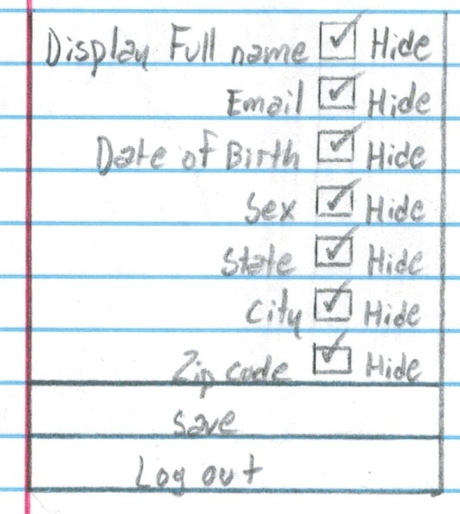 Initially all of the boxes will be checked to ensure that all of the user’s information is hidden on their profiles. If the user chooses to uncheck either of the boxes then their information will be revealed on their profile. Once the user is done making their changes they can click on the save button and the menu will rise up towards the lock button. If the user clicks Log Out then the menu will also rise up in order to close and log the user out of the account.

Referring back to the standard header, the square to the right of the lock button will be the notifications button. The notifications button consists of a flag and a number to represent the amount of notifications that the user has. If the user does not have any notifications then the button will only display the flag **(DESIGNER - needs to design the notifications flag/icon).** We will review the different type of notifications when we discuss the profile pages.

Now we will move on to the first page of the website, the home page.

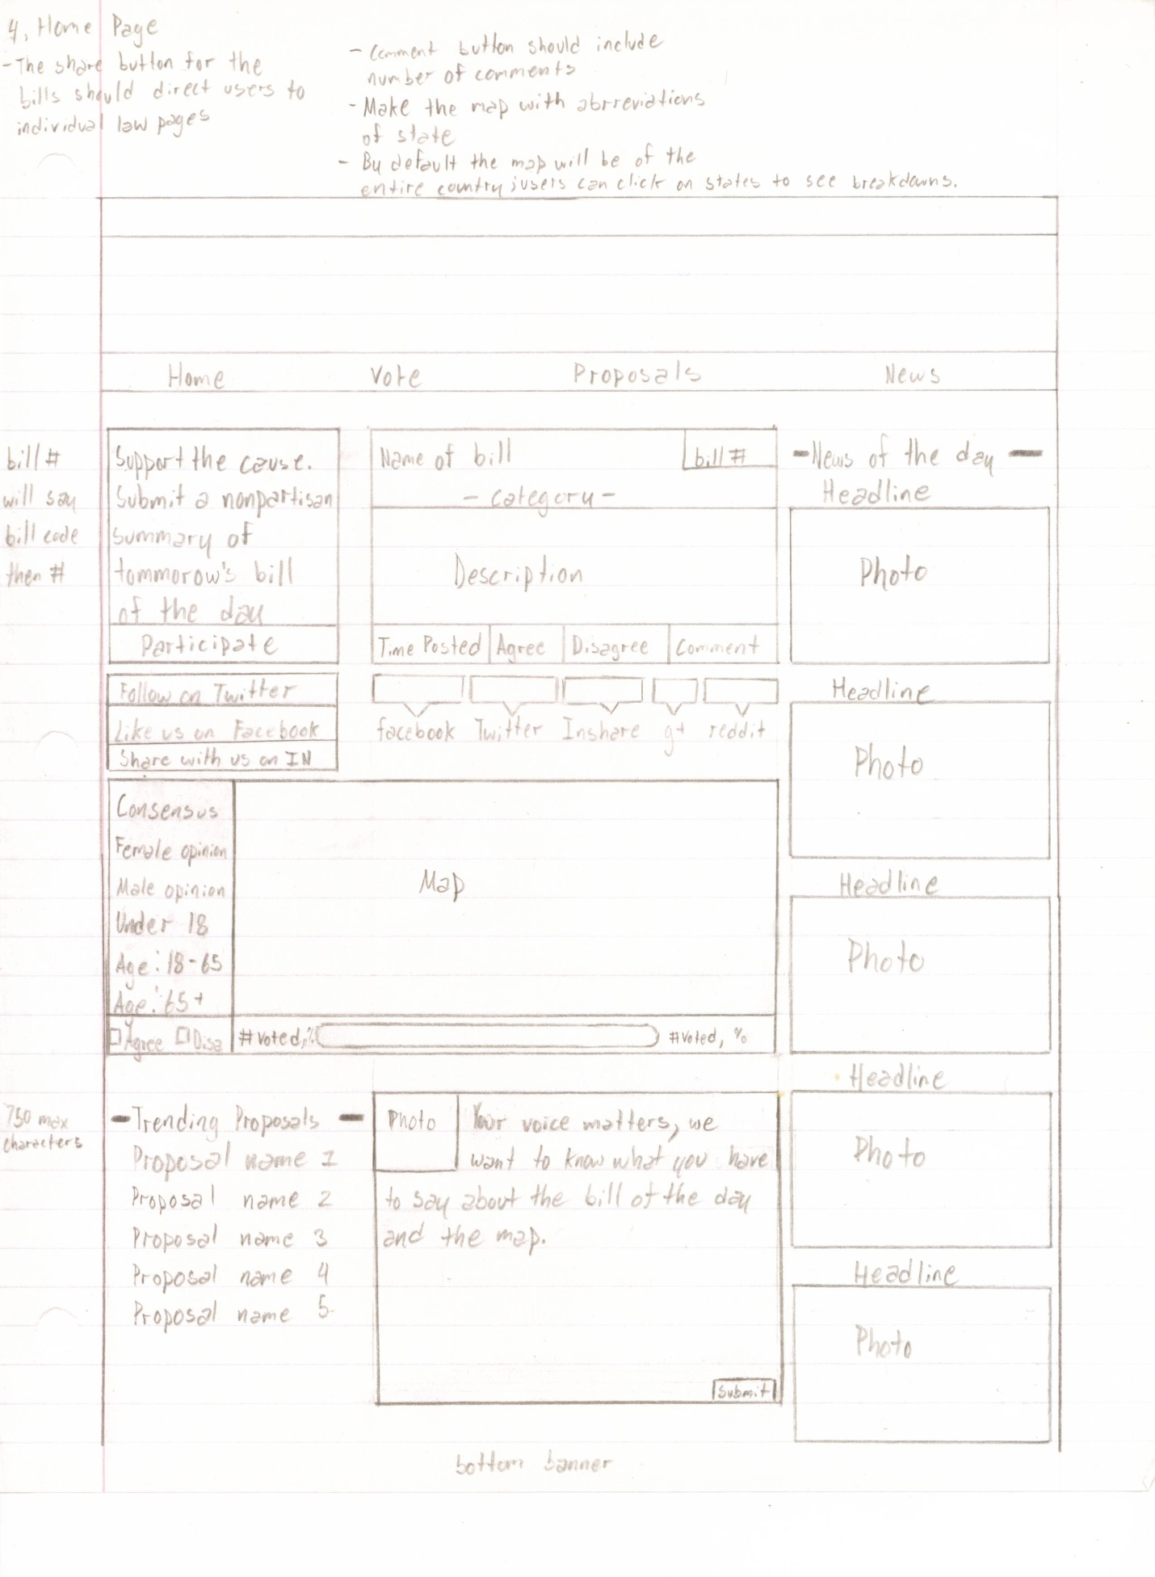**Home Page**

We will review the home page in sections, and begin with the top left section.

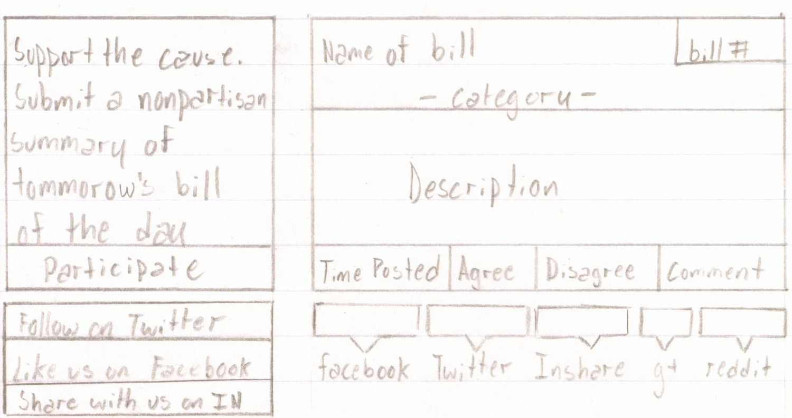

When the user clicks participate they will be redirected to a page that looks like the following: 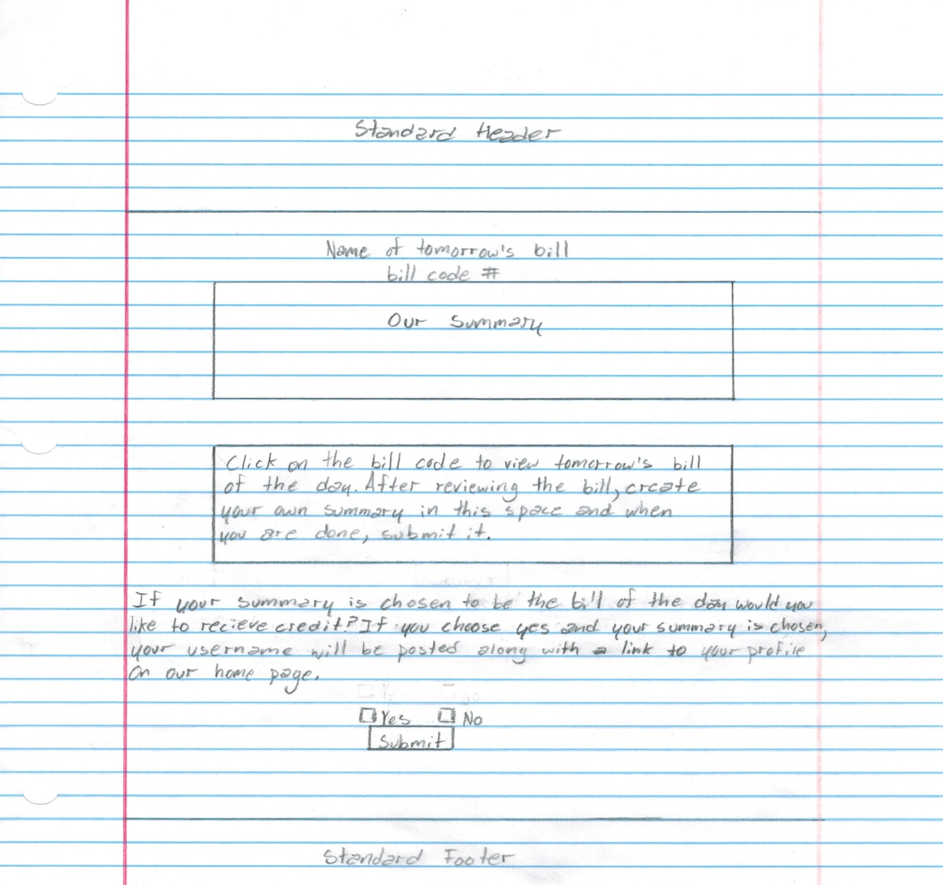

* **P.** The words in the rectangle should appear in a light grey and should disappear once the user clicks on the rectangle.

The three buttons under the “participate” button will allow users to follow our account on their other social media platforms. We will have a page set up on Facebook, Twitter, and Linkedin that they will be able to follow once they click these buttons.

The right side of the image is how the bill of the day will appear. The bill code in the upper right corner of the rectangle will be where we put the code of the bill and it will function as a hyperlink to the original bill on the Senate website. The categories and the description will also be entered by The Fourth Branch’s administrators and will simply be text not hyperlinks. The first rectangle in the bill of the day section is the time that it was posted, and the buttons that follow it are for the user. If a user chooses agree or disagree, both of the buttons will dim and the total number of people who agreed will appear in the agree rectangle and the total number of people who disagreed will appear in the disagree rectangle. Once the user has made a choice they cannot change it. If the user clicks on the comment button then they will be redirected to the individual vote page, which we will review later. The other social network tabs are share buttons and the rectangles above them will show how many users have shared the bill of the day on their other social networks.

* **D.** The color scheme for the maps and the agree and disagree button is a very important decision to make. You have to carefully plan out the colors that will go into this.
* **P.** if a user shares the bill of the day and a friend of theirs clicks on the link from another social network, the link will bring the person to the individual bill page.

Now we will review the lower portion of the home page starting with the map.

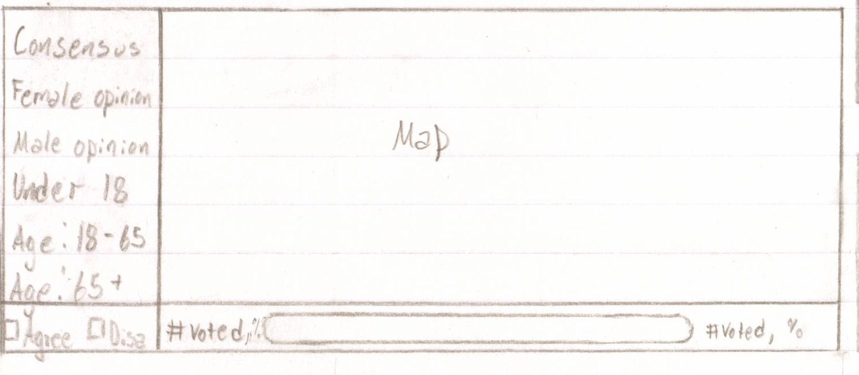

The information on the left is filters for the user to filter the map using different demographics and the rectangle in the bottom left corner will serve as the map’s legend. By default, the map will display all 50 states, these states will be labeled by their abbreviations, ex. New York NY, California CA. If a user scrolls their mouse over a state, the abbreviation should change to the state's full name. If the user has not voted on the bill that the map concerns, then the map will be grey and the bar beneath it will also be grey. If the user tries to click anywhere on the map then the map will dim and a message will appear stating, “vote on the bill to see how your opinion matches up with the nations”.

Once the user votes on the bill, the map will fade in and the colors that match the statistics will be displayed. By default the map will display the overall consensus, and the color of each state will be determined by the majority. The states where most people agreed will be blue and the states where most people disagreed will be red. The same will be the case for the other filters, the only difference is that the statistics will be tailored depending on the selected filter. The colors do not have to be blue and red, but whatever the designer chooses will be the legend, and the legend remains the same regardless of the filter.

* **D.** The color scheme for the map is very important as mentioned above and is a critical design aspect of the website. We need the demographic filter that is selected to have a certain color when highlighted and we obviously need the agree and disagree to be pleasing shades of appropriate colors.

The bar to the right of the legend will display the approval rating of the bill by percentage

ex. If 60% of the people approve of the bill and 40% of the people disapprove of the bill

then the bar will be filled in blue 60% and red 40% (colors arbitrarily chosen, designer needs to choose exact shades and colors.)

On the left of the bar will be the number of people who approved of the bill and their percentage, and on the right side of the bar will be the number of people who disapproved of the bill and their percentage.

The user can choose to click on any state and when they do so, the map will zoom into a picture that is the shape of the state. All of the filters that are on the left side of the map will now become filters for the state map, ex. if the user clicks female opinion, the state will be colored in blue or red by the percentage that agreed and disagreed with the bill, ex. if 57% of the women in the state of New York agreed with a bill, and 43% of the women in New York disagreed with the bill, then 57% of the state of New York will be colored in the agreed color, and 43% of the state will be colored the disagreed color. Visually the agreed color will cover the top portion of the state while the disagreed color will color the bottom portion of the state. The bar will work the same way; now it will display the statistics of the state instead of the national statistics.

Now we will review the bottom portion of the home page.

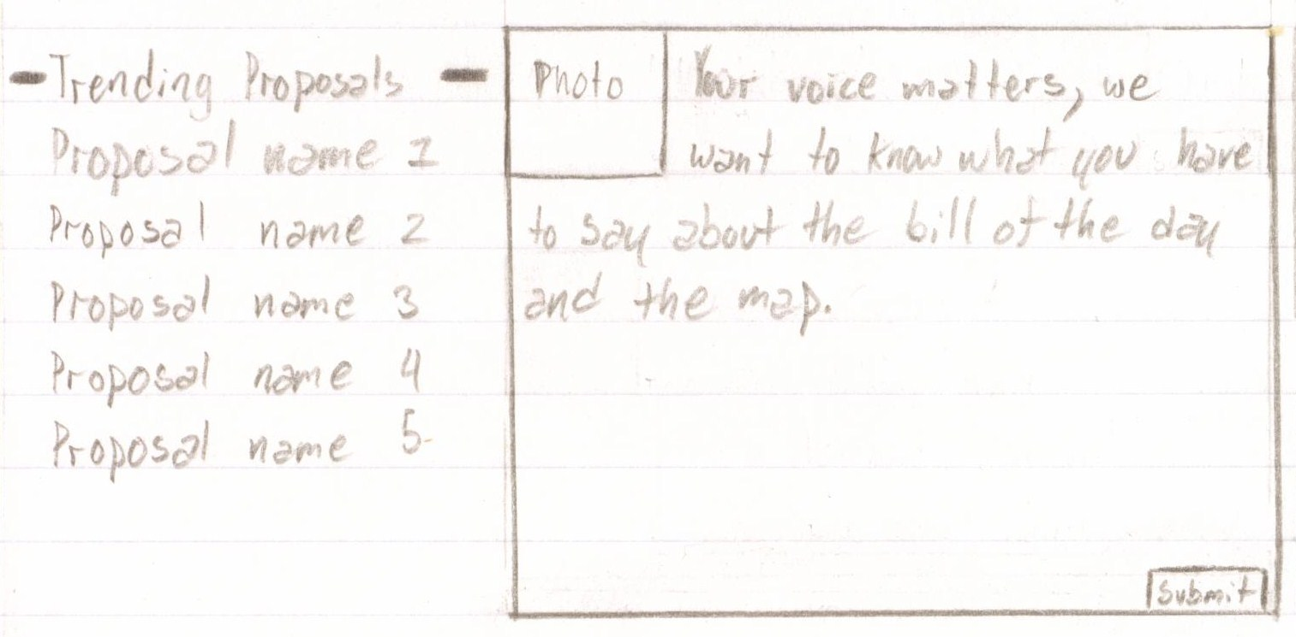

Instead of trending proposals we will have trending comments, and those will be the comments that received the most agrees on the bill of the day. The first 50 characters of each comment will be displayed on the trending comments as their respective "titles". If an individual clicks on a trending comment, it will take them to the individual vote page where all of the comments on the bill are visible. The page will then automatically scroll to where the trending comment is located so that the user may review it.

To the right of the trending comments will be a space for the user to submit their comment on the bill of the day. If the user is logged in then their photo will be displayed in the upper left corner of the comment box, but if the user is not logged in then there will be a photo of The Fourth Branch logo by default. The words in the square should be in light grey and should disappear once the user clicks on the square. On the bottom left of the square there should be a character count which only allows the user to input a maximum of 750 characters.

Next we will review the right column of the home page: the news section.

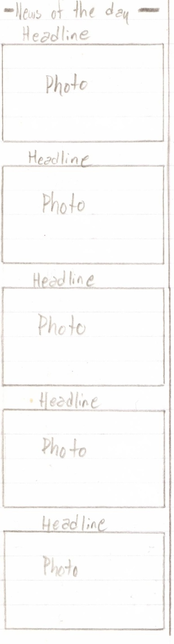The header should read “ Bipartisan News of the Day Generator”. Under that headline will be the same random article generators as are in the news section. Only the image is clickable. Once you click it the generator automatically does the function and another tab opens up with the news article. So for instance say the First topic is Economy, if you click the picture it will randomly generate an economic article from the list of links that we input into the generator that day. In terms of the picture, we want to be able to change it once a day to something new that we like. On the home page we want to have five generators, but in the news section we will have eight.

**- D.** Depending on the size of the features that you make you can add up to eight news generators to the home page if necessary. For now represent them arbitrarily with whatever pictures you want.

Next is the standard footer of the website. This standard footer will be at the bottom of every page, the same way that the top banner will be at the top of every page.

The pages will end first with the same tabs that the top has and then it will be followed by a banner just like the top of the website has(DESIGNER - we need a creative bottom image designed as well, maybe something that compliments the top banner). Under the photo will be tabs to the Contact, Copyright, Privacy Policy, and About sections which are just standard headers, text, and standard footers pages. Below these tabs on the farthest left hand corner will have our slogan and the opposite corner will have our actual copyright info **(not in photo but will be included).**

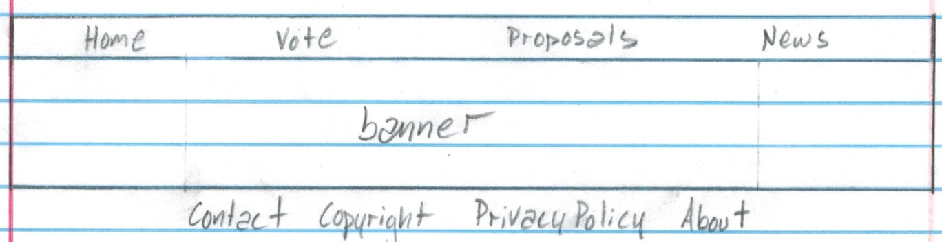

Next we will go through the tabs, so first we will start with the Vote page.

**Vote Page**

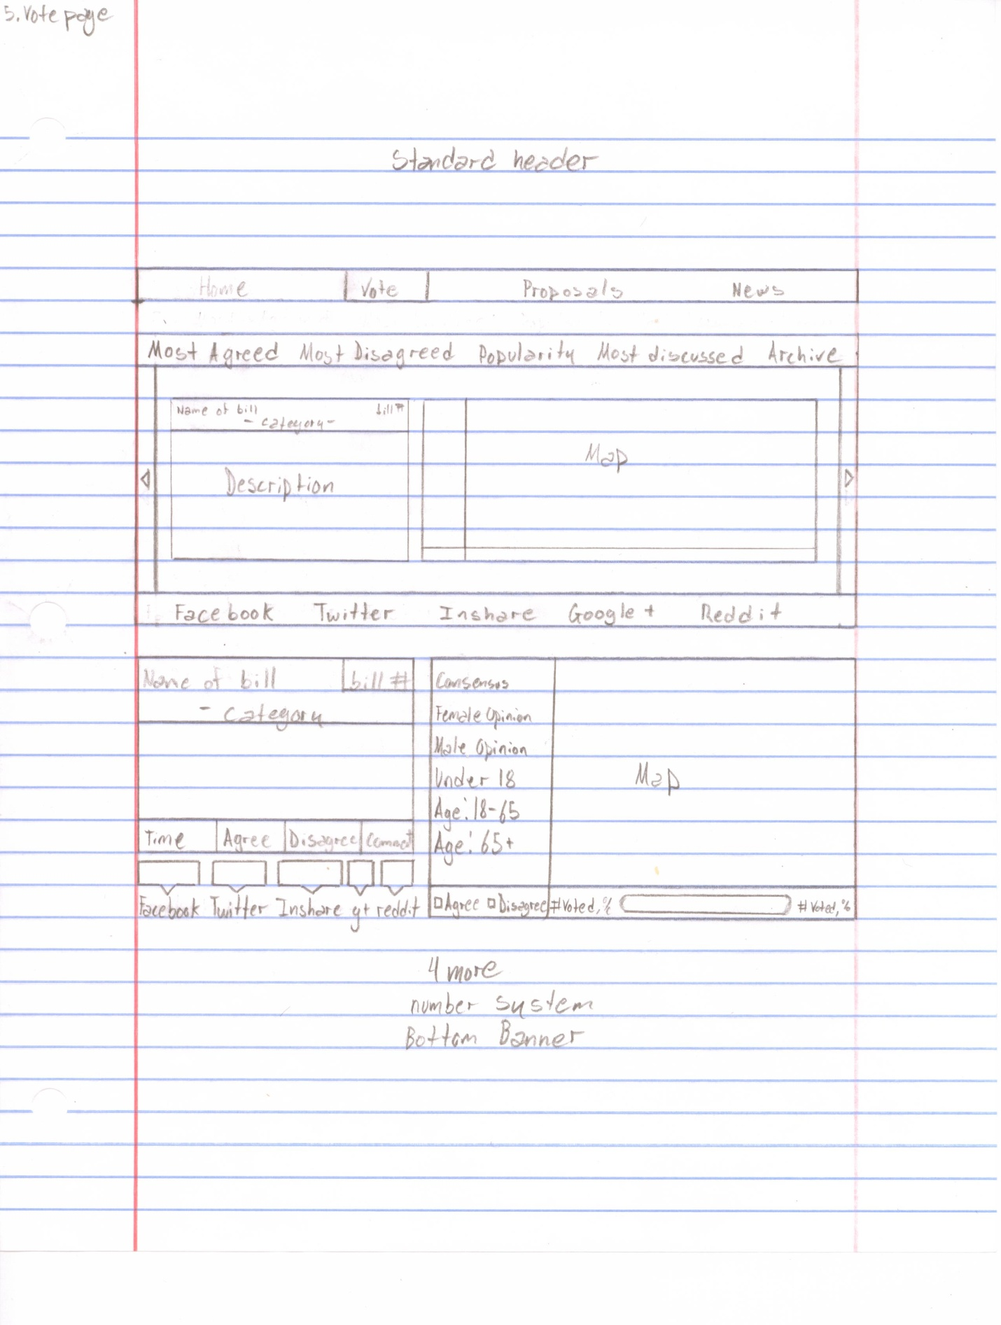

First we will explain the search (Archive) feature that is displayed below:

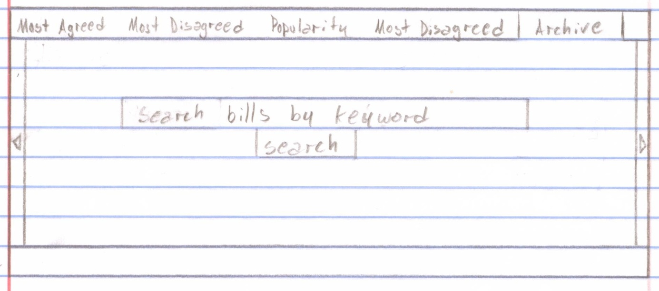

When the user first goes on the vote page, the slider will automatically highlight the archive section. In this section the user will be able to search past bills using a keyword search. Once the user types in the words, they will click search and the bill along with the bill's map will slide to the left and appear in the slider. Individuals will then be able to scroll through their search using the left and right arrow keys at the edges of the slider.

If an individual clicks most agreed on the slider it will automatically filter all of the bills on the website and organize them from most agreed to least agreed within the slider. If an individual clicks on most disagreed on the slider it will automatically filter all of the bills on the website and organize them from most disagreed to least disagreed within the slider. The popularity tab will organize the bills by the most total agrees and disagrees combined. We accidentally put most disagreed twice, instead of the second most disagreed it should read **most discussed**. The most discussed filter will organize the bills by the bills that received the most comments received.



This bar represents various share buttons for various websites. Whenever a bill comes up on the slider for any reason, it will always have the share buttons pertaining to that specific bill, displayed within the slider as well.

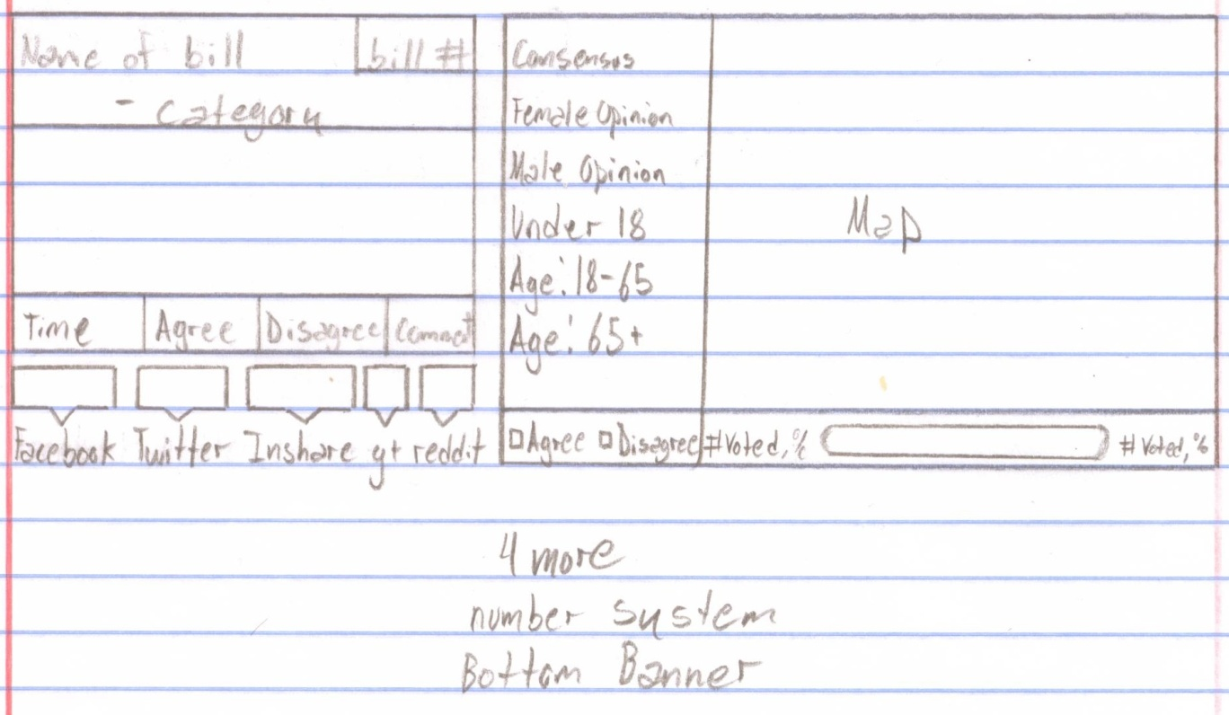

The above image will be located right below the slider on the vote page. This will be the standard representation of bills and maps on the vote page, and will be organized by time (most recent at the top). When an individual clicks on the vote page what they see is the slider as well as five bills and maps below it. Below that will be a button that says view more bills. If an individual clicks view more bills, the page will extend and display five more bills, also organized by time. There will also be a standard footer at the bottom of the page. **Ignore where it says number system.**

**Individual vote page/ Proposal page**

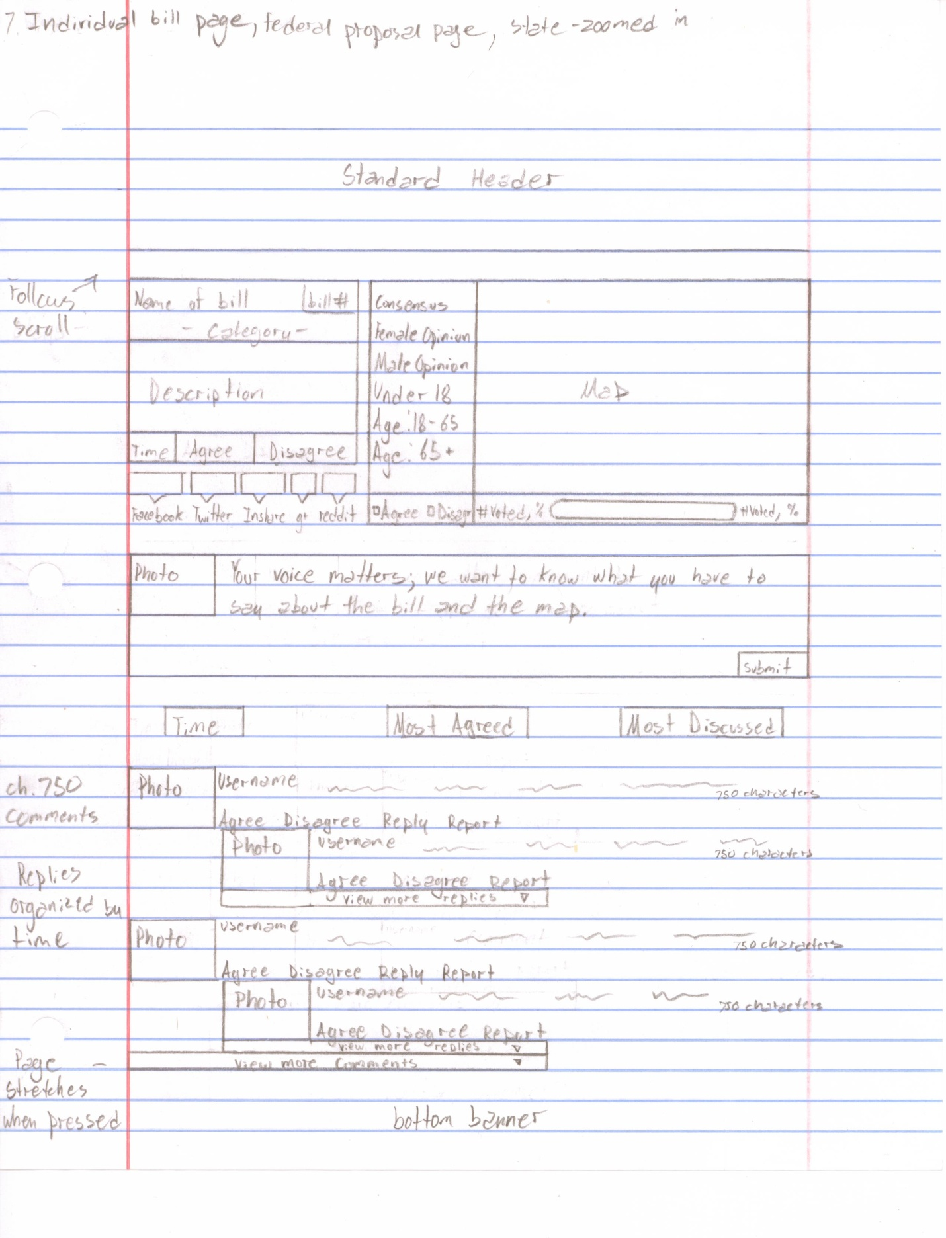

Once an individual clicks on the title of any bill or proposal they will automatically be taken to that bill or proposal's individual page. At the top of the page they will be able to agree, disagree, share, explore the map, and comment on the bill or proposal. In the comment section there should be a character count of 750.

Below the comment will be three buttons that will allow the user to better organize all of the comments on that bill or proposal. Individuals will be able to comment on the bill itself and reply to comments that other users have posted. Users will also be able to agree or disagree with any comment on the website and will be able to see a numerical representation of how many agrees or disagrees the comment received. ex. if a comment received 17 agrees and 10 disagrees, there will be a little green 17 next to the agrees and a little red 10 next to the disagrees.

- **D.** We need you to figure out the colors for the agrees and disagrees and how they will look. Could be red and blue, could be other colors. It obviously depends on your overall design and color scheme for the website.

Users will also have the ability to report any comment if they deem it inappropriate, racist etc. That comment will automatically be removed and we will be made aware of it so that we can either approve or disapprove of the comment. If we approve of the comment then it will reappear as if it were never removed.

- **P.** If a user constantly reports other user's comments and we find that we approve of them, the user will be sent an email with our reporting guidelines. (We will discuss in person).

On a regular basis there will be 10 comments automatically displayed under each individual bill with a button at the bottom that reads view more comments. Once they click the view more comments, 10 more comments will appear. There will also be up to three replies displayed per comment automatically. If you wish to see more replies there will be a view more replies button under the third reply. The photos and usernames of people who made comments will act as hyperlinks to their personal profiles. When a user clicks on reply a drop down will appear beneath the comment they are replying to and it will look like the following image:

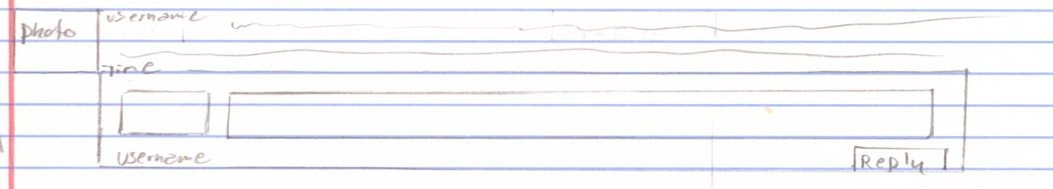

If an individual proposal page concerns a state then the map will only display the state. Proposals will stay open for voting for a year and once they are closed users will no longer be able to vote on them but they can continue to comment, reply, agree and disagree with comments. **Individual bill page after vote**

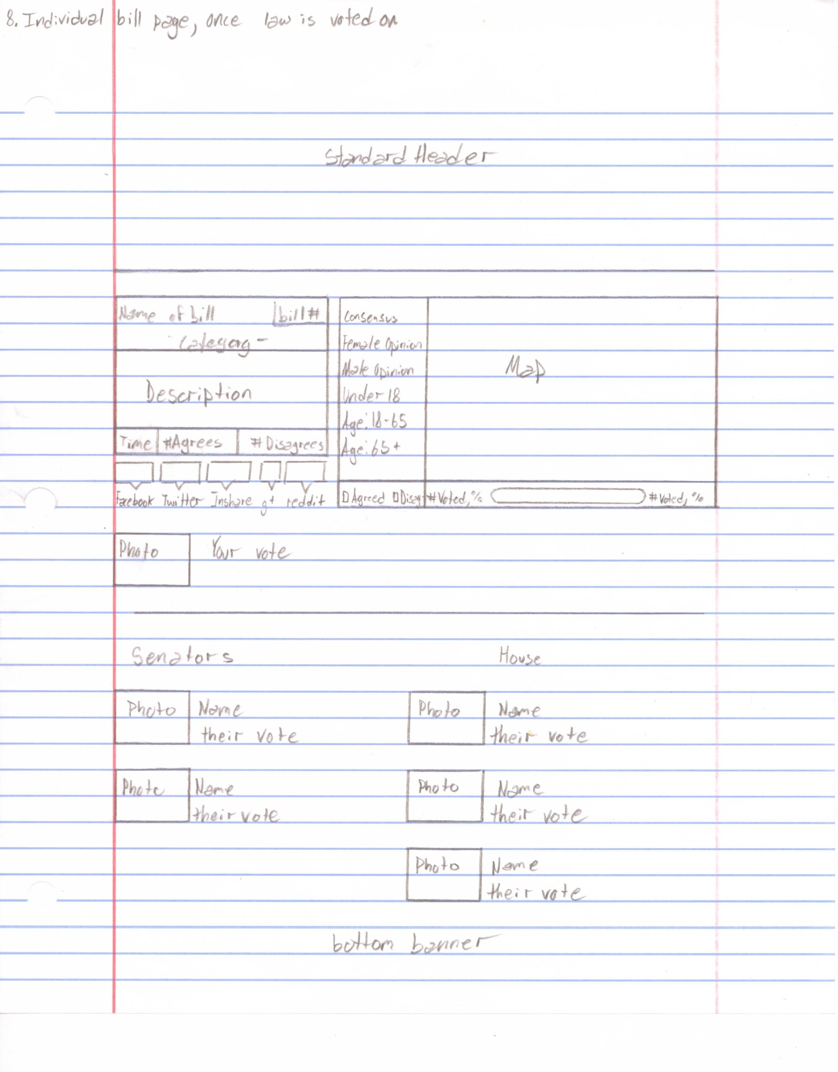

Once a bill is voted on in Congress that individual's bill page will appear as indicated in the picture on the left. Based on which state the user who is viewing the bill is located in, the senators and house of representative officials will change accordingly. The photos will be pictures of the elected representatives taken from their official websites while their votes will simply be text which states whether they voted to pass the bill or reject it.

**Proposal Page**

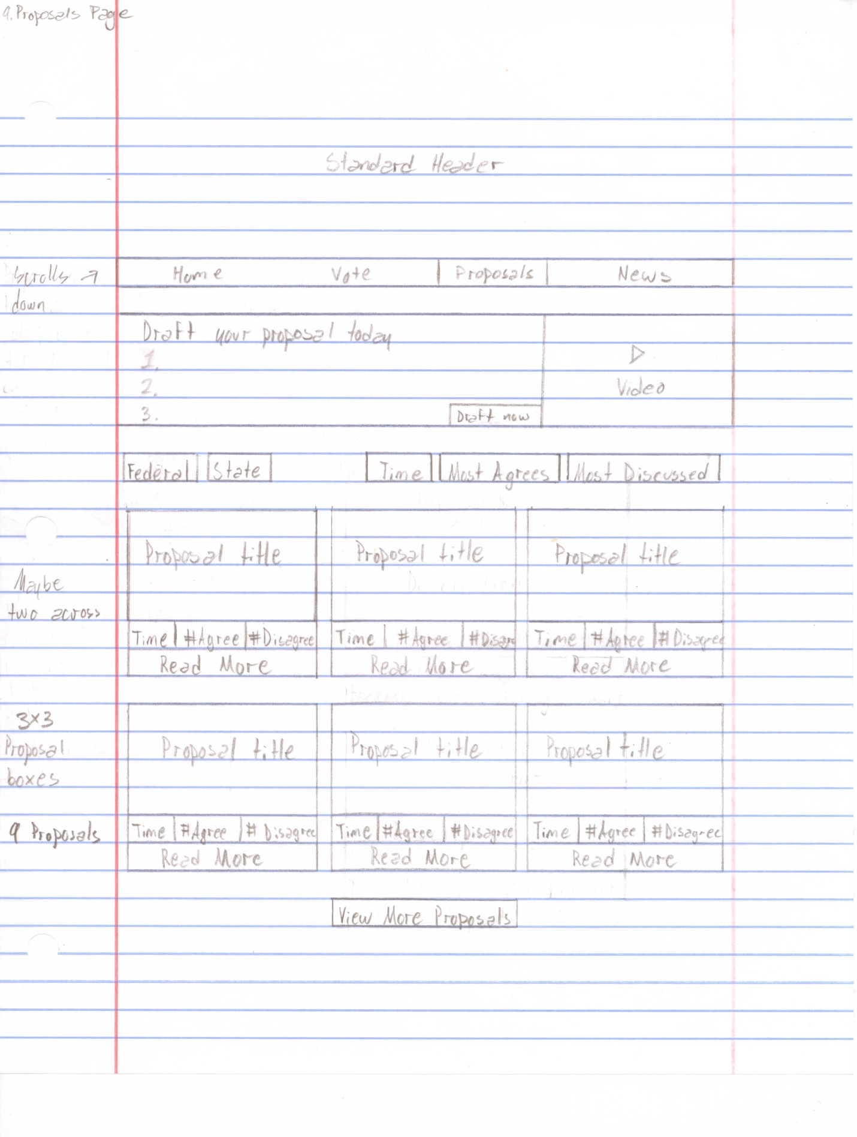

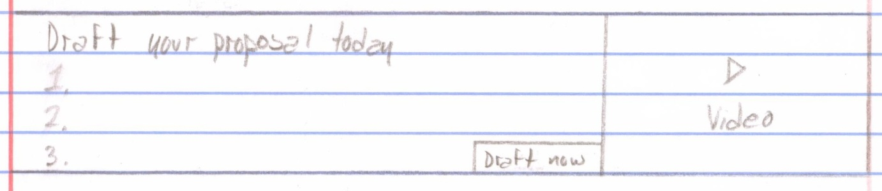

The video will be something that we insert once and individuals will be able to play this video by clicking on it. Once you click on the video it will pop up in the middle of the screen and then it will begin to play. The numbers on the side will be followed by sentences that will explain why individuals should draft their own bills. The draft now button will redirect individuals to the drafting proposals page.

Below the Draft Your Proposal Today section will be the following:

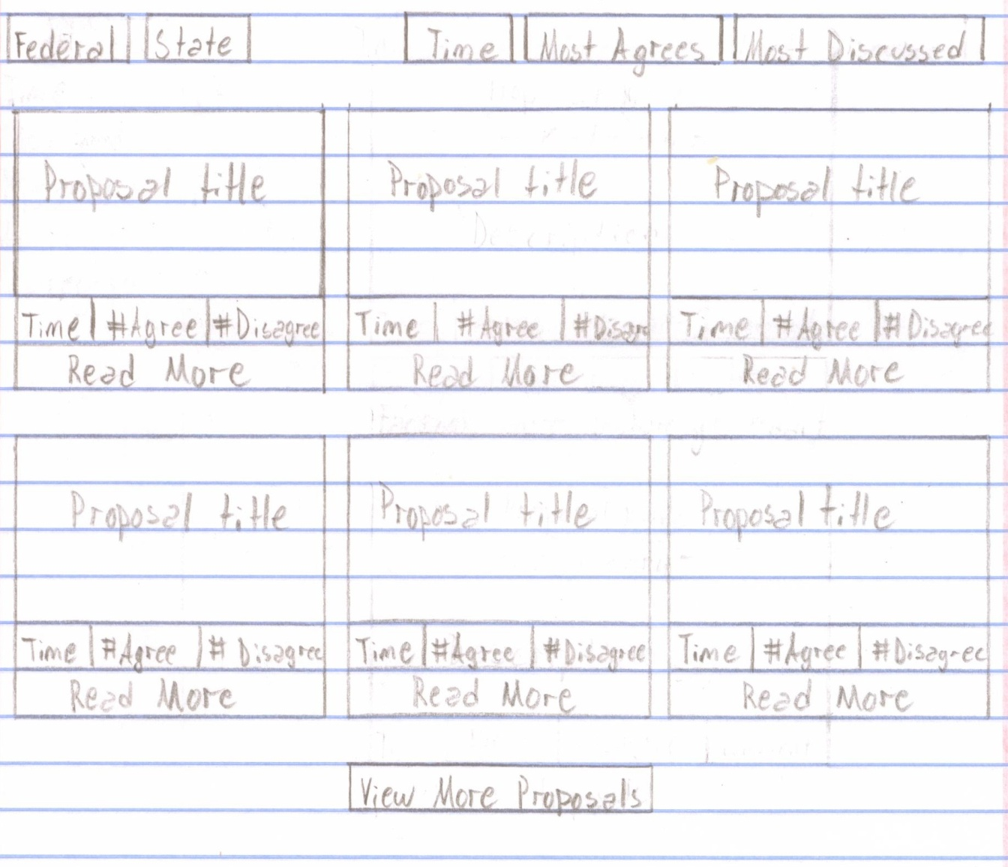

Users will be able to organize the proposals using several categories. By default they will be sorted by Federal laws and the Time they were posted. An individual will have two choices when sorting something. They will choose either Federal or State bills(they have to be signed in to choose state and it will filter to include only proposals about their state) and then they will choose Time, Most Agreed, or Most Discussed proposals. Time sorting is by most recent postings, Most Agreed will be by the most agreed upon proposal, and Most Discussed will be the Proposal that got the most comments.

The standard page will display 9 proposals in a three by three matrix, however you would be able to click view more proposals at the bottom of the page in order to expand the page downward. This expansion will also be defined by the constraints of the search options that the individual picked at the top of the page. There will be a standard footer at the bottom of the page.

When viewing the proposals all users will see is the Proposal title, the time the proposal was posted and the number of agrees and disagrees it received. They will not be able to vote or comment from this page since they do not see the full proposal summary. In order to see the summary, users will need to click read more and they will be redirected to that specific proposals page.

**Draft Now Page**

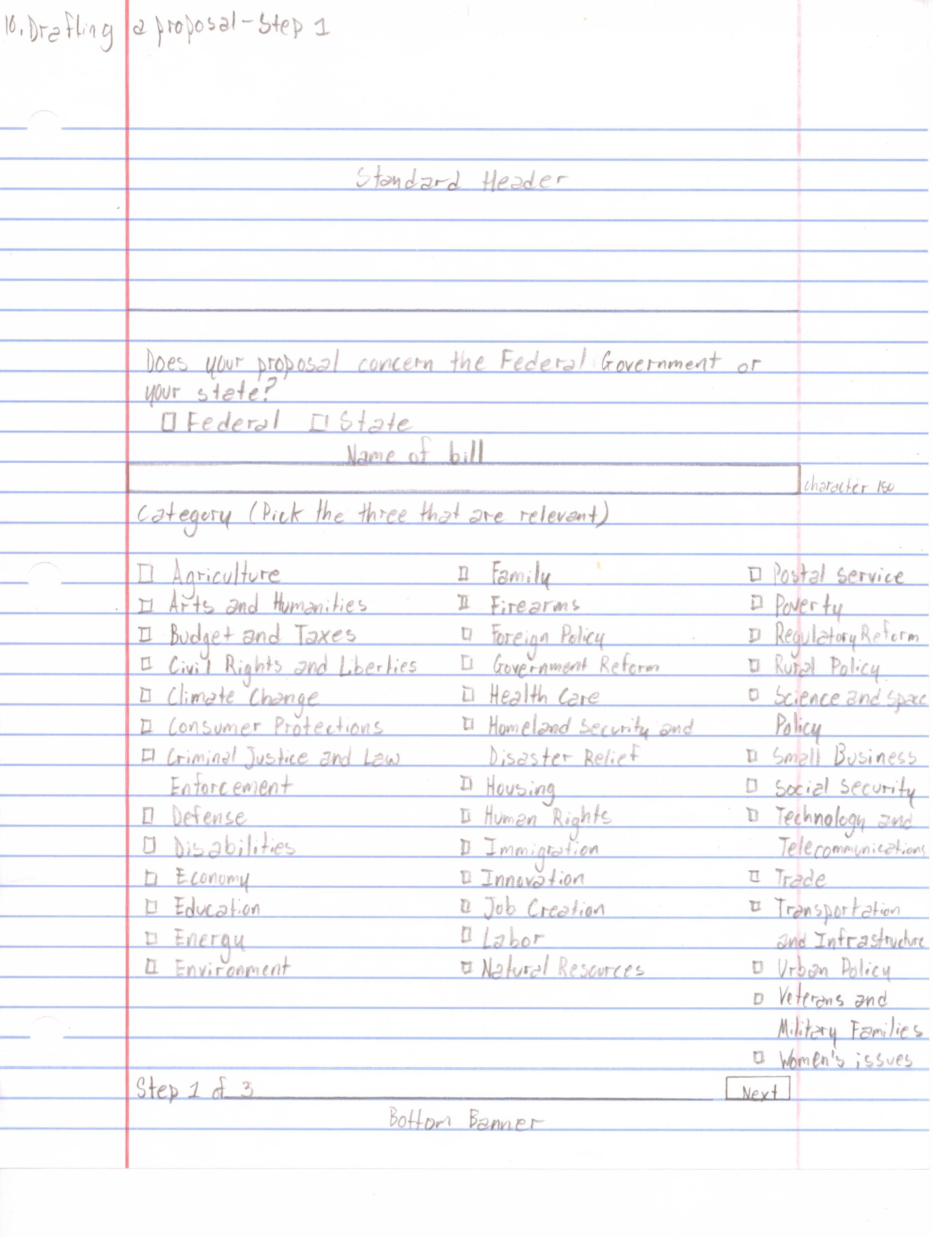

When a user clicks on the draft now button they will be redirected to the first step of the drafting process. The user must answer the first question of whether their proposal concerns the Federal Government or the State they live in and then choose three categories that their proposal concerns. Once the user is done choosing their categories they will press next to proceed to the second step in the drafting process.

**- D. We cannot display the categories in the fashion that we displayed them in. We need another way of displaying these categories but we could not think of a better way to do so.**

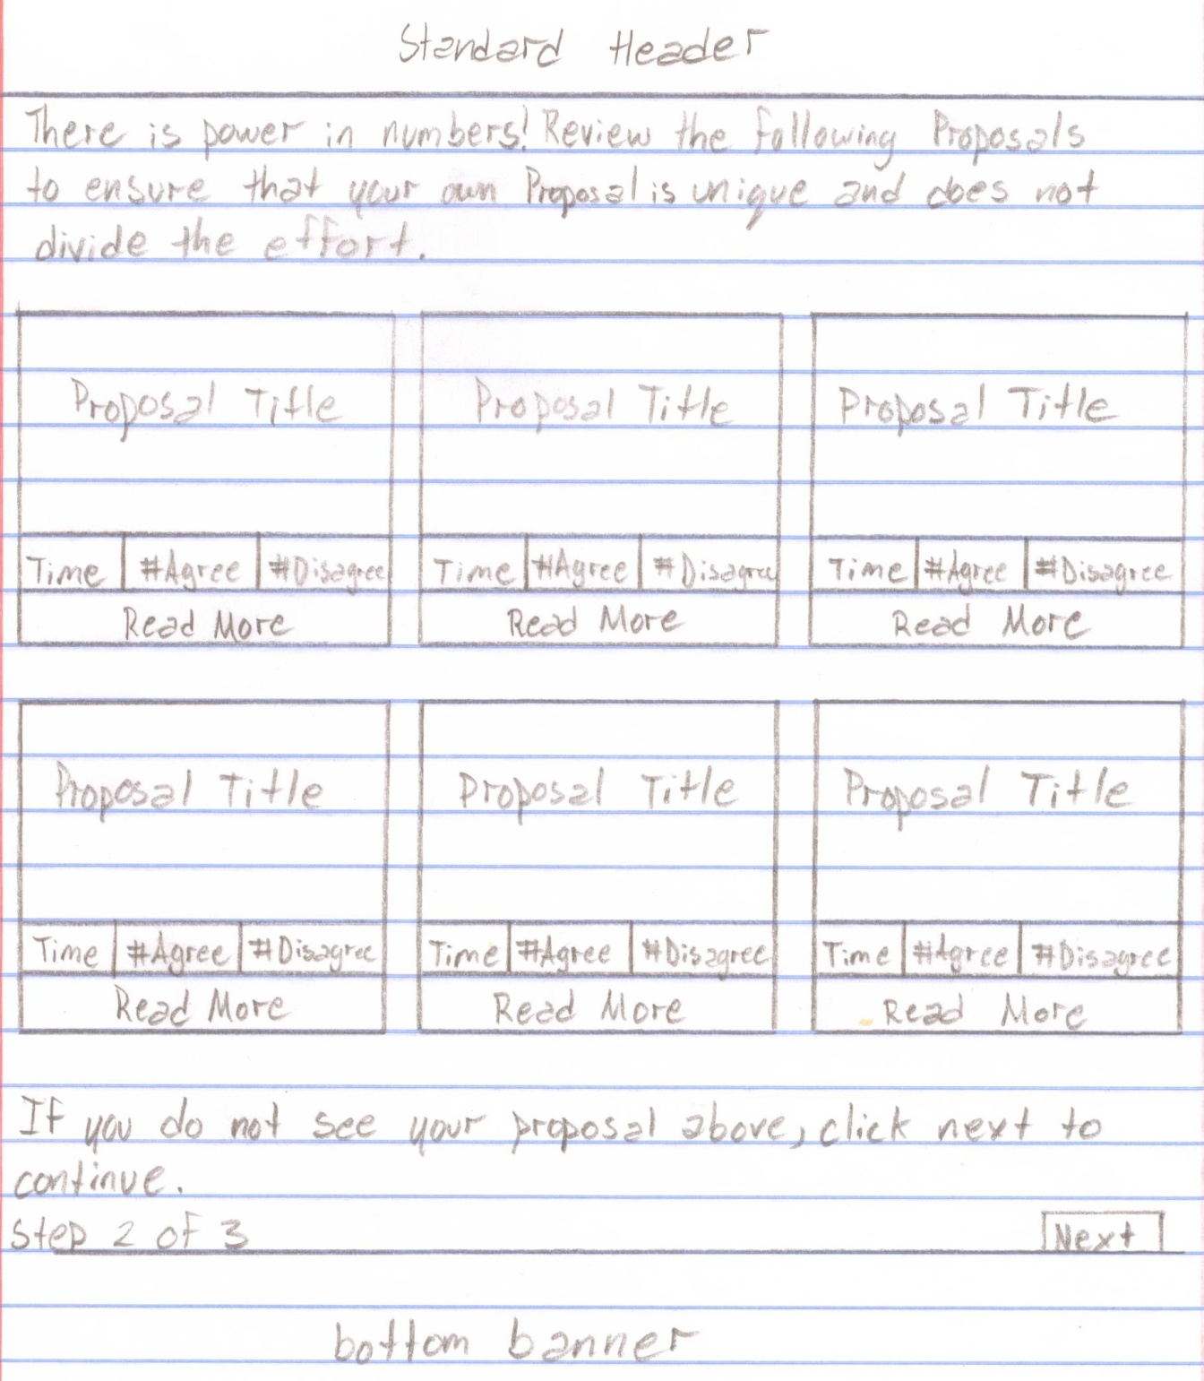

In the second step of the drafting process the users will be referred to proposals that may already address the issues that the user intends to write a proposal on. They can click on any of the proposals that appear and review them to see if they are similar. If the user clicks on a proposal in this search feature and decides that his proposal is unique, all he has to do is click the back button on his browser to return to the second step of the drafting process. If the user believes that his proposal is unique he can then click next to proceed to step three.

- **P.** The proposals that are referred will come from a match in the categories that were chosen by the user along with a keyword search of the title that the user entered.

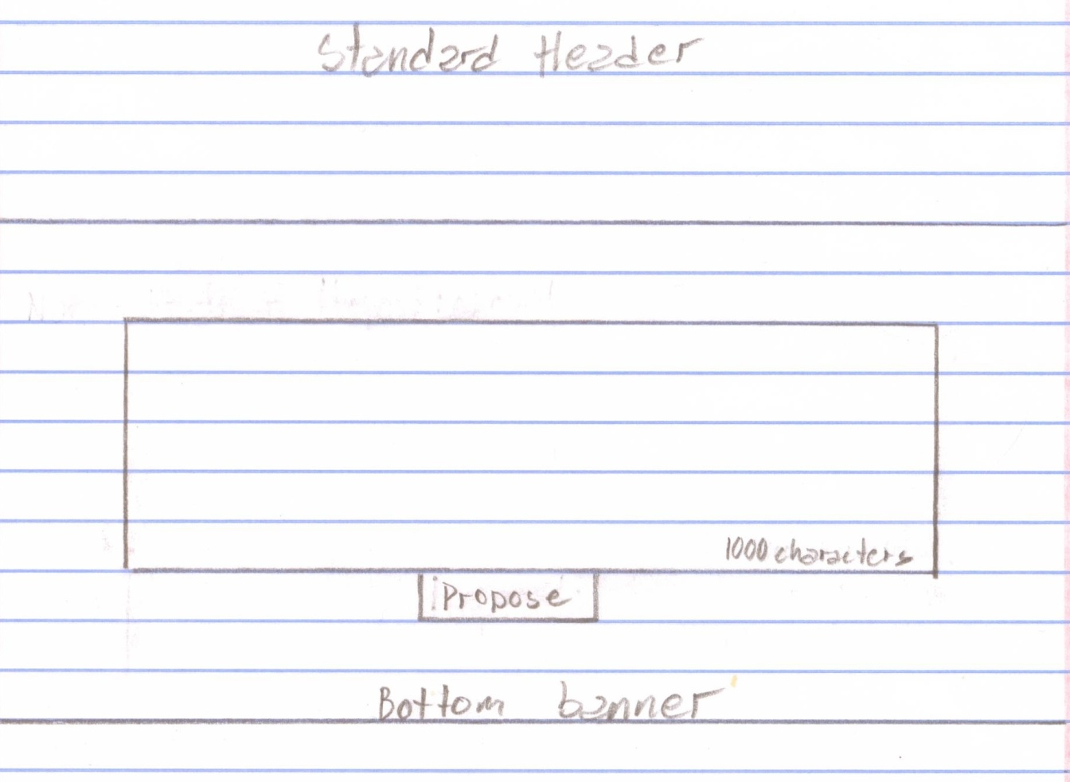

This will be the final step of the proposal process. Above the rectangle where the user is to draft their proposal should be the title that the user entered in the first step of the process. Once the user has written their proposal they can click submit and the following will appear:

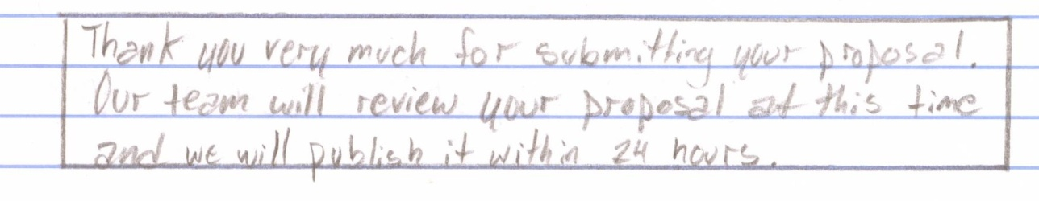

Once we approve of the proposal it will be posted on the website.

Next we will review the news section.

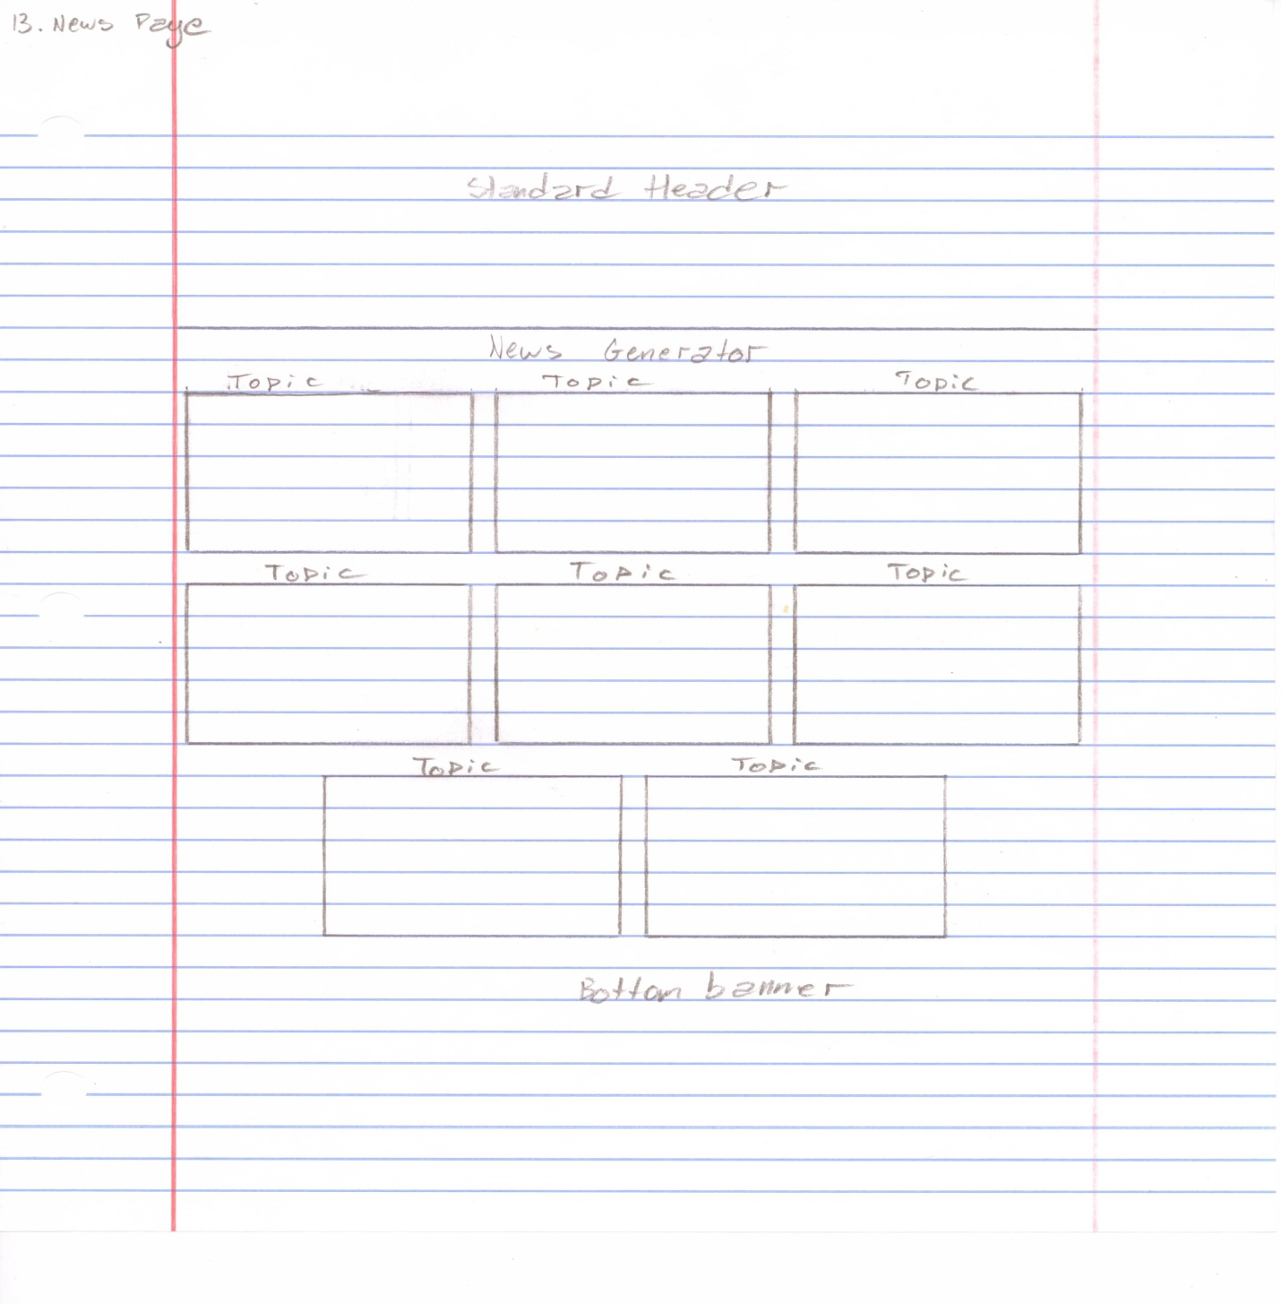

**- D. Make this look nice.**

- **P.** If individuals were to share these boxes on their other social networks, would it be possible to make it so that when they click on the link it automatically generates an article from our database in a separate tab on their browser.

The squares will represent different news generators and will have photos in the squares.

Next we will review the Individual Profile Page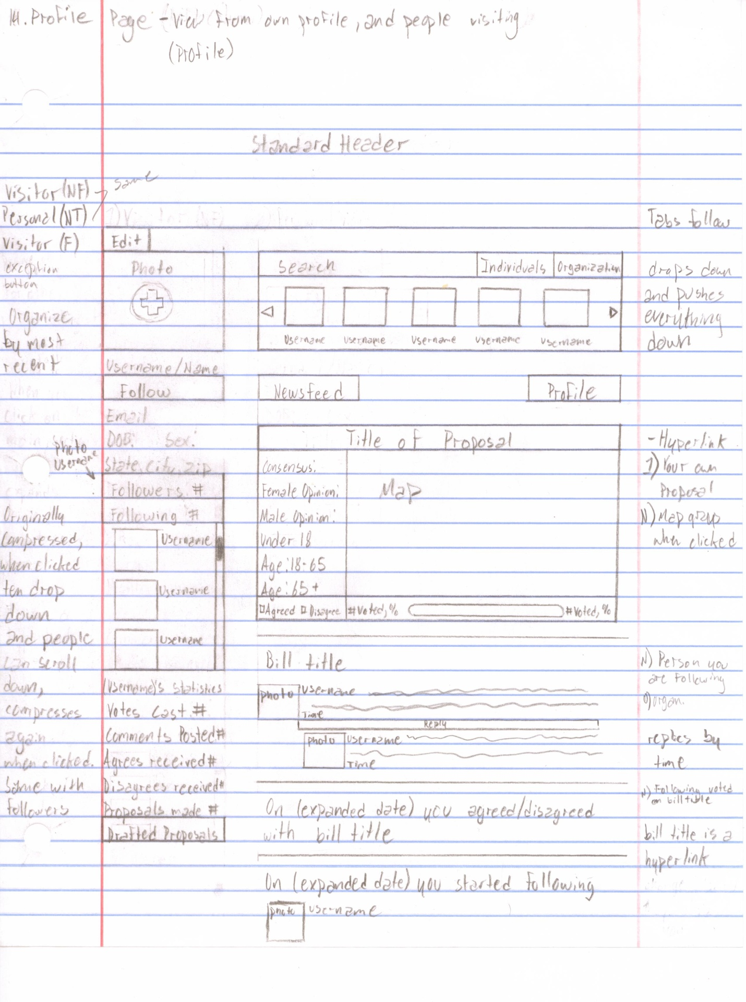

First we will take a look at the left column of the Individual profile page.

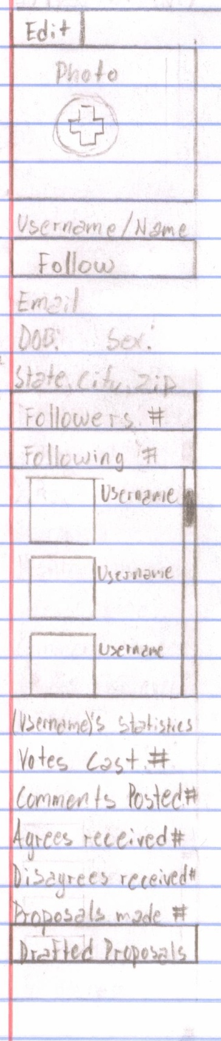

The edit button will only appear when a user is viewing their own profile. If they click the edit button, they can then change their photo, email, state, city, and zip code. Once the user clicks on the edit button, the button will change and read "done". Once the user makes all of their desired changes they can click done and their changes will be saved.

If the user is looking at their own profile then the follow button will not appear on the page. The follow button will only appear on the page if a user is visiting the profile page of another user and they are not already following the profile. If they are already following the other user then the button will read unfollow.

The followers and following tabs will by default be compressed and expand to reveal ten users when they are clicked. The tabs should display the amount of people who are on each list at all times. Below the tabs will be the site statistics of the user. The statistics will be split into five categories: number of votes cast, number of comments posted, number of agrees received, number of disagrees received, and amount of proposals made. Below the statistics will be another tab that expands when clicked and display the titles of the drafts proposed by the user. When the tabs are expanded the user can scroll down within the box to view other profiles, the profiles will be organized according to time. ex. the followers tab will display the newest follower first and the following tab will display the newest person the user has started following. If an expanded tab is clicked again then it will compress back into the tab.

Next we will look at the search bar.

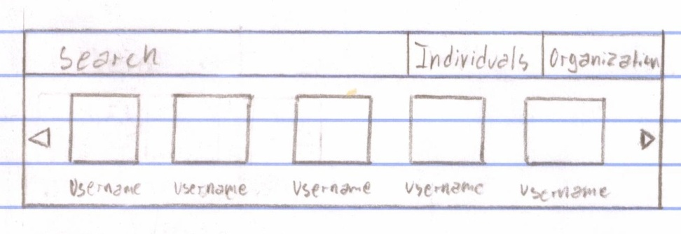

Initially the search bar is compressed to one single line. This search bar is specifically to find users and organizations. After the user types in the username or organization name that they are looking for they will have to click on the button that is appropriate for their search. ex. if the search is for a user they will click individual, and if it is for an organization they will click organization. Once the user chooses how they will search a menu will drop down and display the most relevant result first. If the user does not find what they are looking for with the initial search then they can choose to look through the searches by clicking the arrow to the right. The bar will display five profiles at a time and will show a new set of five when the user clicks the arrow.

Next we will take a look at the possible newsfeed items.

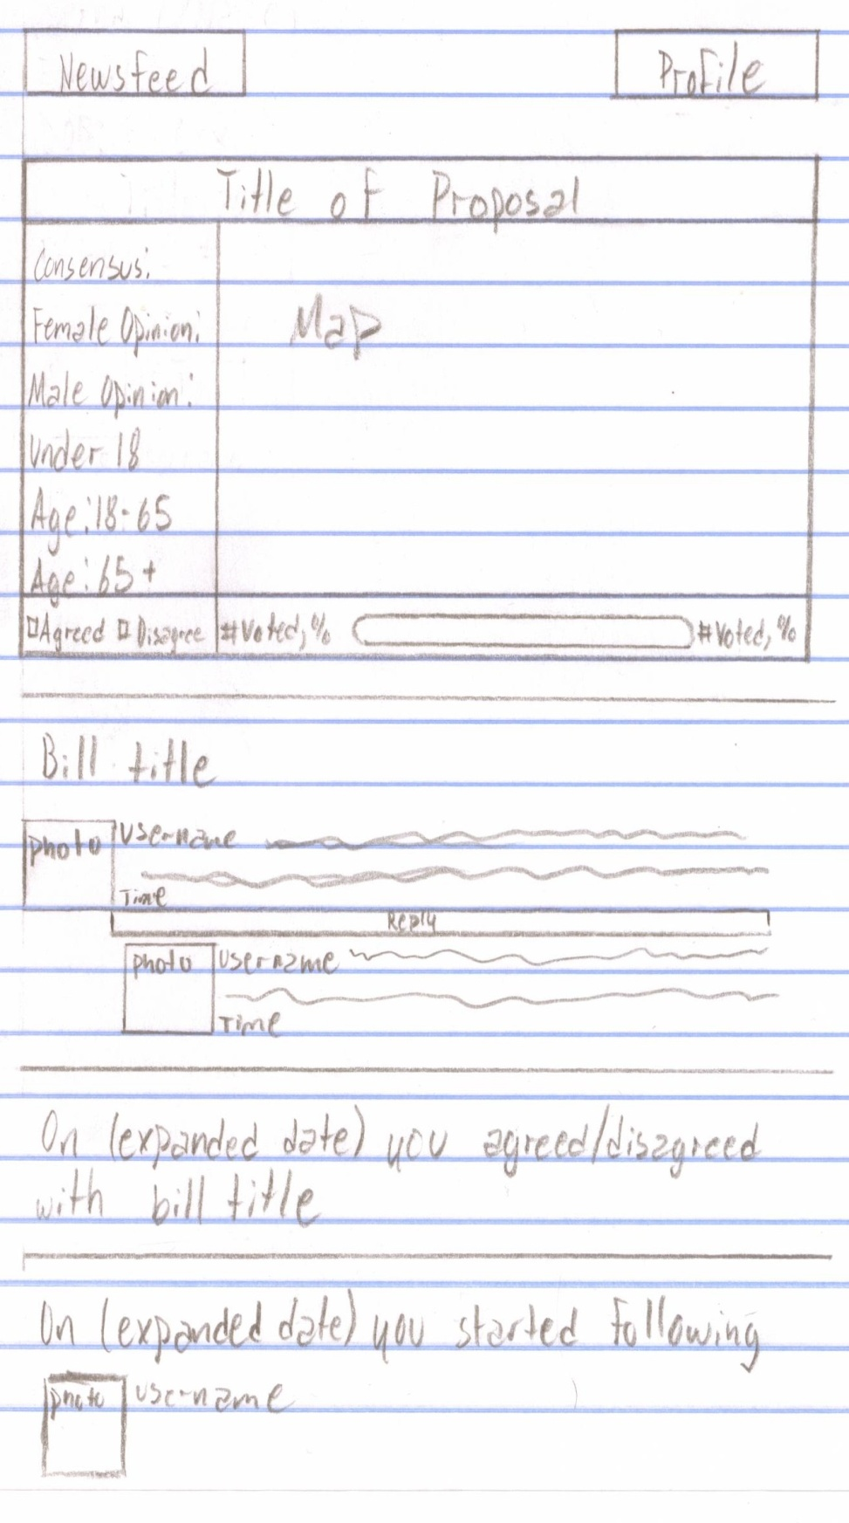The user can view the profile's newsfeed in two different ways. The user can choose to view the regular newsfeed with the option on the left, or they can choose to look at their own profile. Now we will review the four possible newsfeed items.

1.If the user is following someone who has made a proposal then the map of the proposal will appear in the person's newsfeed. If the user already voted on the proposal then the statistics of the proposal will be displayed on the map, if not then the map will be grey. Title of the Proposal is a hyperlink to the individual proposal.

2.Whenever a person who the user is following comments on something, the user will get to see their comment. The user can choose to click on the bill title and they will be redirected to the individuals comment on the bill page or they can directly reply to the comment from their profile.

3. The user will be able to see whether the people who they follow, agreed or disagreed with a bill or proposal.

4. They will see when someone started following them.

If the user is looking at their own profile, the different types of newsfeeds will be the same except when it reads whether the person agrees or disagrees it will read, "you agreed/disagreed with 'bill title'". It will also display who you started following rather than who started following you.

Whenever Congress has voted on a bill and the user voted on the bill, a newsfeed message should pop up that reads, "Bill name - 'bill title' has been voted on by Congress. See the results here". Here should be a hyperlink that takes the user to the individual bill page once the bill went to a vote. In the individual bill page the user will be able to see how their representatives voted.

Next we will look at the organization profile.

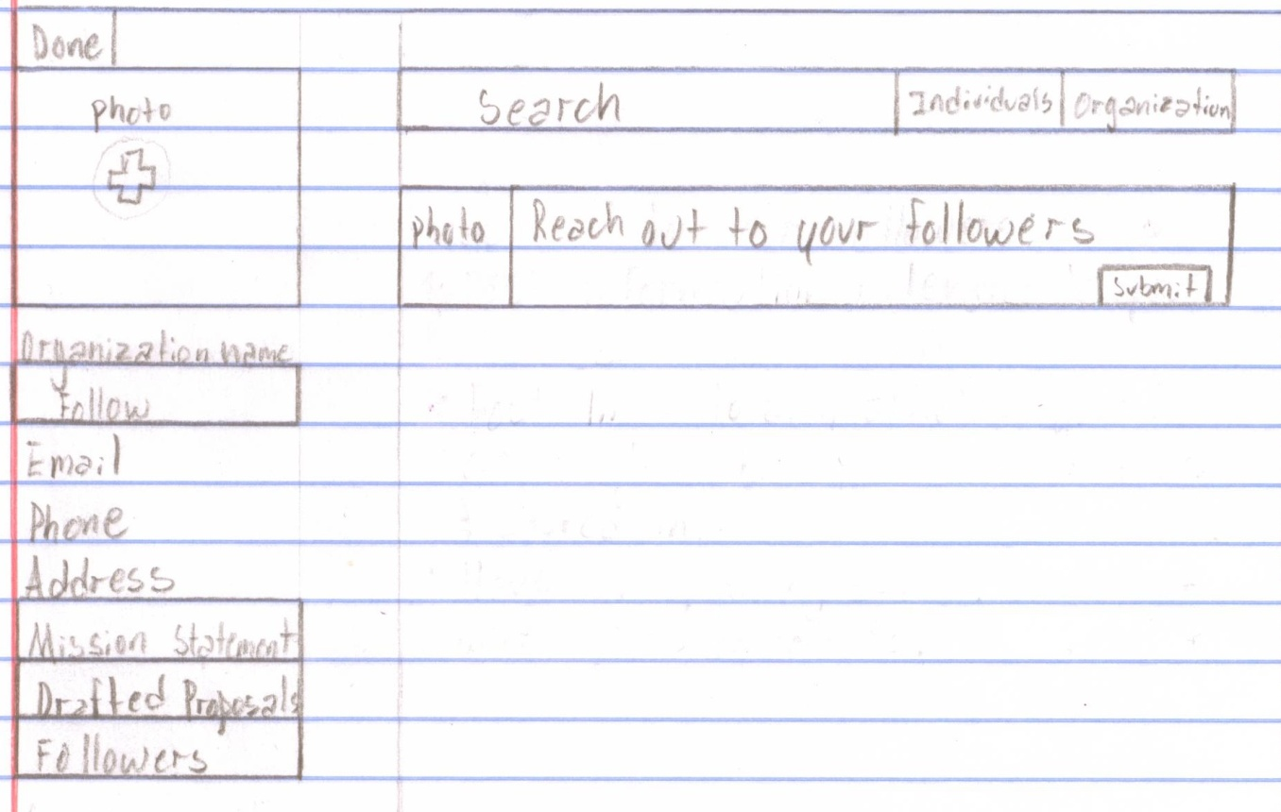

The major differences between the individual profiles and the organization profiles is that the organization profiles cannot hide their information and they are allowed to post statuses. In addition to the tabs that the individual profile has, the organization profile also has a mission statement and the mission statement tab is initially expanded. The status bar will display the organizations photo to the left and then they can type in their status in the space that is provided.

In addition to those changes in profiles, the organizations cannot follow users, they cannot vote on bills or proposals. The organizations will have their personal profiles which will show all of their activity, but the organizations cannot have a newsfeed filled with content from other users since they cannot follow other users.

Finally we will review the notifications.

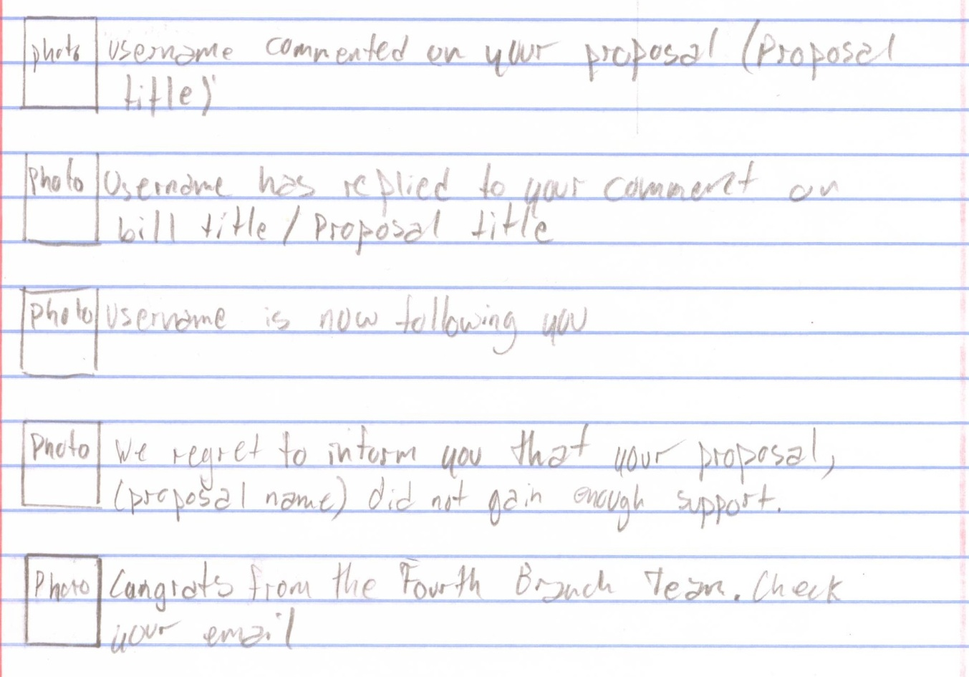

The notifications will drop down once the user clicks on the notifications tab. There are five different notifications that a user can receive. The notifications were drawn big so that you can see them, but the notifications should be a single line and should not take up much space.

1. If a user comments on your profile you will receive a notification

2. If a user replies to your comment you will receive a notification

3. If a user follows your profile you will receive a notification

4. If a your profile fails to obtain the necessary agrees they will receive a notification that will read, "we regret to inform you that your proposal, "proposal name" did not gain enough support"

5. If a your proposal obtains the necessary agrees then the notification will read, "Congrats from The Fourth Branch Team. Check your email!"

With the exception of the last notification., if the user clicks on the notification they will be redirected to the exact location of the activity. The organization profiles will have the same notifications.

This concludes our guide through The Fourth Branch website, if there are any questions or concerns, feel free to contact us at any time.